**Notice of Funding Opportunity**

State Agency Name: Iowa Workforce Development

Funding Opportunity Title: Future Ready Iowa Employer Innovation Fund - Round 1

Announcement Type: Initial

CFDA Number (if applicable): Not applicable

**Important Dates**

* Deadline: Applications for the first round of funds are due by **Thursday, August 1, 2019 at 11:59 p.m. Central Time. Subsequent application deadlines will be determined depending on the availability of funds after the first round is awarded.**
* Application Notification: A Notice of Intent to Award will be posted on the Future Ready Iowa website <https://www.futurereadyiowa.gov/innovation>.

**Program Description**

1. **Purpose**

The purpose of the fund is expanding opportunities for more Iowans to earn for-credit and non-credit postsecondary credentials leading to high-demand jobs and encouraging Iowa employers, community leaders and others to collaborate to support regional workforce talent development. Future Ready Iowa establishes the goal of 70 percent of Iowans in the workforce having education or training beyond high school by the year 2025, but also seeks to strengthen the talent pipeline longer term. Iowa’s current attainment level has stalled at around 58 percent. To help change this, the fund will award competitive grants to support regional initiatives that accelerate credential attainment. Iowa Workforce Development is seeking collaborative applications that propose new, cutting-edge ideas as well as proven strategies.

The purpose of this Notice of Funding Opportunity is to solicit applications that will enable Iowa Workforce Development (IWD) to award grant funding to match local investment and support the goals of the Employer Innovation Fund and Future Ready Iowa.

1. **Funding Priorities**

IWD seeks to prioritize the investment of resources in the following areas:

1. Innovative and creative initiatives lead by employers to address local needs and expand opportunities for credit and noncredit education and training leading to high-demand jobs.
2. Earning of high-demand credentials by Iowans from underrepresented populations (African-American, Hispanic, American Indian/Alaskan, Native Hawaiian/Pacific Islander).
3. Strategies that increase the number of eligible students receiving financial assistance under the Future Ready Iowa Skilled Workforce Last-Dollar Scholarship or Skilled Workforce Grant Programs.
4. Proposals that include performance-based bonuses for high school students who earn national-industry-recognized credentials in high-demand fields.
5. Proposal’s connection to high-demand jobs from the State Workforce Board list, regional community college lists, locally identified high-demand jobs or non-credentialed programs supported by regional or statewide data, innovative measures, geographic diversity and equity.
6. Proposal expands internships leading to high-demand jobs.
7. Proposal includes community engagement with community partners or incorporating existing community programs.
8. **Performance Measures**

All applications must include performance measures that logically connect a project’s goal(s) with proposed activities and demonstrate an overall theory of change. Performance measures should include to the extent possible whether the expected results were achieved.

1. **Program Authority**

IWD’s authority to award these grants is found in the Future Ready Iowa Act of 2018 (Iowa House File 2458).

1. **Definitions**

*Internship*: Temporary employment of a student that focuses on providing the student with work experience in the student’s field of study.

*High-demand job:* A job identified by the workforce development board or a community college pursuant to Iowa Code §84A.1B, subsection 13A.

*Outcome:* A type of performance measure that indicates progress toward achieving the intended result of a program and usually represents a change in the situation of beneficiaries of a service, such as completing a training program or securing employment upon completion of training provided.

*Participant:* A reportable individual who has received grant-assisted services.

**Award Information**

1. **Estimated Available Funds**

The State of Iowa has appropriated $1.2 million to support the Employer Innovation Fund. The source of funding is state appropriated and subject to annual appropriations.

1. **Estimated Award Amount**

IWD anticipates awarding grants ranging from $1,000 to $50,000. However, since there is not a maximum award amount applicants may submit a request for a grant in excess of $50,000. Grant awards may vary in amount as determined by the scope of the project. Funding decisions are made as funding is available and IWD is not obligated to provide the maximum grant amount requested. If more funds are requested than are available, funds will be awarded proportionately to eligible proposals to provide the greatest amount of support across all eligible applicants.

1. **Project and Award Period**

The period of performance for this award is one year. Applicants should plan for a 12-month budget period. IWD estimates the following project dates:

* Start Date: October 1, 2019
* End Date: September 30, 2020

Dates are tentative and are subject to change. Final dates will be determined during the award process.

1. **Type of Award**

IWD may award cost reimbursement grants to successful applicants.

1. **Use of Funds**

The Employer Innovation Fund can be used to support credit and non-credit programs, along with wrap-around support programs such as child care, transportation, books, equipment, fees or other innovative ideas and proposals that can assist Iowa residents in completing training and education. It cannot be used for administrative expenses of operating the program or implementing the project.

1. **Cost Sharing or Matching**

The Employer Innovation Fund is a match grant. What this means is that the grant is intended to serve as a match to funds raised privately by the applicant. Applicants may request an Employer Innovation Fund match grant for an amount up to the amount of the private funds raised.

Applicants must prove the existence of and security of the original funds in order to qualify for a match from the Employer Innovation Fund. Documentation must be included in the application submission as an attachment. Proof may be provided by an official statement from an FDIC-insured financial institution holding the funds. In the absence of a statement from a financial institution, an affidavit from a certified public accountant can be used to certify the existence and security of the funds to be matched.

Housing expenses, such as rent, do not qualify for consideration for matching funds, nor do administrative or personnel costs for overseeing a project or implementation of a plan.

1. **Reporting Requirements**

Successful applicants will be required to submit reports to document the progress of the project as part of the grant requirements. Annually, all grantees must provide a detailed report of the use of funds by December 31st of the reporting year to the Director of Iowa Workforce Development. The report must include, but is not necessarily limited to:

* Date funds received
* Amount of funds received
* Amount of funds provided by the employer
* The numbers of individuals, agencies and businesses and others who received the funds
* Balance of available funds remaining as of December 31st of the reporting year
* A description of the activities paid for by the funds, the dates of distribution, along with amounts disbursed for each activity, and the number of participants served
* The persistence and/or completion rate for individuals supported by the award, including the specific credit or non-credit program completed
* Employment and wage outcomes after completion

1. **Payment Schedule**

The executed grant agreement will specify conditions for payment and payment schedule. Private funds must be expended first, then matching funds may be drawn down on a reimbursement basis.

**Eligibility Information**

1. **Eligible Applicants**

Eligible applicants include employers, employer consortiums, community organizations or other entities that are in good standing with the State of Iowa. IWD encourages applicants to cultivate partnerships to enhance project activities and outcomes. If an employer is not the lead applicant, applicants are required to include a letter of commitment from an employer as a key project partner with the application submission.

Grantees must comply with all applicable provisions of state and federal laws pertaining to nondiscrimination, sexual harassment, and equal employment opportunity.

1. **Additional Consideration**

Additional consideration will be given to organizations that demonstrate the administrative capacity and a history of successfully implementing innovative projects. Additional consideration will also be given to organizations and projects in local workforce areas and regions throughout the State of Iowa that document how the project will impact workforce, education and economic development.

**Application and Submission Information**

1. **Electronic Submission Instructions**

Applicants must submit applications electronically via IowaGrants.gov. IWD recommends that applicants create an account and begin the application in advance of the deadline. For registration guidance, refer to “IowaGrants.gov New User Registration Instructions” (see Appendix D)

The applicant’s authorized representative must be the person who submits the application. The authorized representative must be using his or her own IowaGrants.gov account in order to sign and submit the application.

Official email communication from IWD regarding this application will be issued from [iowa.grants@webgrantsmail.com](mailto:iowa.grants@webgrantsmail.com). Applicants are required to assure these communications are received and responded to accordingly.

1. **Content**

Applicants will enter or attach the following components of a complete application in IowaGrants.gov:

* General Information
* Narratives:
  + Executive Summary
  + Project Design
  + Performance Measures
  + Organizational Capability
* Application Budget
* Application Attachments
* Authorization, Assurances, and Certification

See Appendix A for further instructions and application guidance.

1. **Submission Dates and Times**

Please see the Important Dates section at the beginning of this announcement for the submission deadline. IWD reserves the right to extend the submission deadline and any notice of such extension will be posted on IWD’s website and/or IowaGrants.gov.

Attempted submission of a completed application after the stated due date and time will not be allowed by the system. If a submission is attempted after the published date and time, the applicant will receive a notice stating “The Funding Opportunity is closed.”

**Application Review Information**

1. **Criteria**

|  |  |
| --- | --- |
| Demographics | 10 points |
| Goals and Measurements | 20 points |
| Plan | 50 points |
| Budget | 20 points |
| Total | 100 points |

See Appendix C for a full description of criteria and a scoring rubric.

1. **Review and Selection Process**

A review team will use the criteria listed in this section to review applications under this funding announcement.

1. **Applicant Clarification**

Some applicants may receive requests to provide clarifying information and/or make changes to their application including changes to the budget. This information is used by IWD staff in making funding recommendations. Applications may be recommended for funding even if they are not asked clarification questions. A request for clarification does not guarantee a grant award. Failure to respond to requests adequately and in a timely manner may result in the removal of applications from consideration.

1. **Selection for Funding**

Decisions to award grants and the funding levels will be determined per application based upon compliance with the requirements of this funding announcement. Applicants may be selected to enter into a grant agreement, finalizing grant terms, budget, scope-of-work provisions, at which time the final decision to make a grant award will be made.

**Awarding Agency Contact(s)**

Please direct any questions regarding this NOFO to:

Kathy Leggett

[Kathy.Leggett@iwd.iowa.gov](mailto:Kathy.Leggett@iwd.iowa.gov)

Iowa Workforce Development

1000 East Grand Avenue

Des Moines, IA 50319

Please direct any questions regarding IowaGrants.gov to:

David Parziale

[David.Parziale@iwd.iowa.gov](mailto:David.Parziale@iwd.iowa.gov)

Iowa Workforce Development

1000 East Grand Avenue

Des Moines, IA 50319

**Technical Assistance**

Technical Assistance (TA) will be provided throughout the application process, in the form of webinars and direct support. A TA schedule will be available on the Future Ready Iowa website and regularly updated.

**Other Information**

1. If an applicant fails to meet any eligibility criterion at the time of an application deadline, the application may still be reviewed but the State will not make an award until all eligibility criteria are met.
2. IWD reserves the right to request additional information from applicants to evaluate applications.
3. IWD, at its sole discretion, reserves the right to reject all applications; to reject individual applications for failure to meet any requirement; to award in part or total, and to waive minor defects and non-compliance. Such a waiver will not modify the program requirements or excuse the applicant from full compliance with program specifications or grant agreement requirements if the grant is awarded. Submission of an application confers no right to an award or to a subsequent grant agreement.
4. All application submissions become the property of IWD. If funds are awarded, the contents of all applications will be in the public domain at the conclusion of the selection process and will be open to inspection by interested parties subject to exceptions provided in Iowa Code Chapter 22 or other provision of law.
5. IWD is not obligated to award any grants under this program, to pay any costs incurred by the applicant in the preparation and submission of an application or pay any grant-related costs incurred prior to the grant beginning date.
6. All decisions by IWD are final.
7. Upon IWD approval, the successful applicant will receive a grant agreement via email from IWD. The applicant has 10 working days to sign the grant agreement. If the agreement is not executed within 10 working days, IWD reserves the right to cancel the award. IWD, at its sole discretion, may extend the time period for executing the grant agreement.
8. Any grant agreement awarded by IWD shall include specific provisions, terms, and conditions.

**APPENDIX A: Future Ready Iowa Employer Innovation Fund Application Guidance**

Please review the following guidance when preparing your grant application. The application includes a General Information section, Narratives, Budget, and Attachments. Each section includes prompts that must be addressed.

**General Information**

In IowaGrants.gov, complete the General Information section. On this form, applicants will enter basic information about their organization including:

* Legal Organization Name
* Organization type (Government, Nonprofit, Institute of Higher Education, Business, etc)
* Organizational DUNS Number
* Business Address
* Contact information of person for program matters
* Contact information of person for business/administrative matters
* Contact information of your organization’s Authorized Representative

Applicant’s will also enter basic information regarding the application including:

* A project title
* Your project’s proposed start and end dates
* Estimated grant funding and match (if applicable)

**Executive Summary**

Provide a summary that identifies and describes the:

* Applicant
* Amount of private funding leveraged and match funding requested
* Geographic region and community(ies) to be served
* Members of partnerships (if applicable)
* Services to be provided
* Whether the program will offer academic credit
* Anticipated goals and outcomes of this project

**Program Design Narrative**

* Describe the proposed project and identify proposed activities and goals. Include an outline of a proposed project timeline with key milestones.
* Describe how your project will expand opportunities for credit and/or noncredit postsecondary education and training leading to high-demand jobs for Iowans. Include a description of local barriers and how you plan to implement innovative strategies to meet the need.
* Identify which high-demand job(s) the project intends to support. Describe your justification for determining the job(s) as high-demand (State Workforce Board high-demand job list, regional community college list, linked to locally identified high-demand jobs as demonstrated by statewide or regional data, etc).
* Describe the need for the project and how it will lead to increased skilled workers to fill high-demand job(s).
* Describe the community or geographic region serviced. Describe how the project will address areas of workforce need throughout the region.
* Describe the demographics of participants. Identify a number and percentage goal for engagement of students or learners from underrepresented populations (African-American, Hispanic, American Indian/Alaskan, Native Hawaiian/Pacific Islander).
* Describe key partners, roles, responsibilities and how they will contribute to the success of the project.
* Describe how the project’s goals tie to the larger Future Ready Iowa goal.
* Describe any supportive services or additional benefits of the project. For example, the project will:
  1. Provide assistance to pay for related expenses such as books, equipment, transportation, child care, or other wrap-around support services.
  2. Increase the number of eligible students receiving financial assistance under the Future Ready Iowa Last-Dollar Scholarship or other Future Ready Iowa Grant programs
  3. Provide performance-based bonuses paid when high school students earn national industry-recognized credentials aligned with high-demand jobs.
  4. Expand internships leading to high-demand jobs.

**Performance Measures**

* Clearly identify key performance measures including outputs and desired outcomes. Examples include:
  1. Number of participants enrolled
  2. Number of participants from an underrepresented population enrolled
  3. Number of participants completing program and received credential
  4. Increased diversity of participants
  5. Number of participants with secured employment in a high-demand job
* Describe your plan and ability to track and measure each outcome.
* Describe how you will measure the success with an emphasis on enrollment and project completion.

**Organization Capability Narrative**

* Describe the related experience of the applicant and partners (if applicable) responding to the funding announcement. Subcontracting to implement the program will not be permitted.
* Provide information about the applicant’s size, structure, as well as the length of time in business.
* Include a list of the applicant’s staff, including partner staff, to be assigned to the project. Describe the role each staff person will fulfill as well as the primary person who will serve as the lead point of contact for the project to IWD. Include a description of relevant work experience.

**Budget Narrative**

* Complete the budget form and provide a narrative justification of each cost category including how each proposed cost in the budget is calculated.
* Describe your plan for utilization of both the private funds and the Employer Innovation Fund match grant.

**Application Attachments**

Upload the following in the Attachment section in IowaGrants.gov.

* Supporting documentation of match funds
* Letters of commitment from key partners

**APPENDIX B: Employer Innovation Fund Frequently Asked Questions (FAQ)**

**1.** **What is the purpose of the Iowa Employer Innovation Fund?**

The purpose of the fund is expanding opportunities for more Iowans to earn for-credit and non-credit postsecondary credentials leading to high-demand jobs and encouraging Iowa employers, community leaders and others to collaborate to support regional workforce talent development. Future Ready Iowa establishes the goal of 70 percent of Iowans in the workforce having education or training beyond high school by the year 2025, but also seeks to strengthen the talent pipeline longer term. Iowa’s current attainment level has stalled at around 58 percent. To help change this, the fund will award competitive grants to support regional initiatives that accelerate credential attainment. Iowa Workforce Development is seeking collaborative applications that propose new, cutting-edge ideas as well as proven strategies.

**2.** **What for-credit and non-credit post-secondary credentials qualify?**

Qualifying credentials include post-secondary certificates, diplomas or two- and four-year degrees leading to high-demand jobs. Education or training programs do not have to be Pell Grant eligible to qualify for the Employer Innovation Fund. They can be shorter than 15 weeks.

**3.** **Who will decide which applications receive funding?**

Iowa Workforce Development will identify application panels to review and score proposals. Each panel will consist of three to five individuals from different regions representing multiple perspectives. The number of panels will depend upon the number of applications received.

**4.** **What will Iowa Workforce Development take into account when determining grant awards?**

Iowa Workforce Development will evaluate applications based on a number of criteria including but not limited to the scoring guidance referenced in the to the scoring rubric.

A. The proposal’s connection to high-demand jobs from the State Workforce Board list, regional community college lists, locally identified high-demand jobs supported by regional or statewide data, innovative measures, geographic diversity and equity.

B. Whether the proposal increases the number of Iowans receiving financial aid to earn for-credit credentials from the Future Ready Iowa Last-dollar Scholarship or Future Ready Iowa Grant programs; or support for related expenses such as books, equipment, transportation, child care, and other wrap-around assistance to help new high school graduates and adult learners complete education or training for high-demand jobs.

C. Whether the proposal includes performance-based bonuses paid when high school students earn national industry-recognized credentials aligned with high-demand jobs that meet regional workforce needs.

D. Whether the proposal expands internships leading to high-demand jobs.

E. Whether the proposal offers innovative ways of expanding opportunities to earn for-credit and non-credit credentials for education or training leading to high-demand jobs.

F. Whether the proposal addresses areas of workforce need throughout the region.

G. Whether the plan includes community engagement by including community partners or incorporating existing community programs.

**5.** **Will work-based learning be an allowable use of the Iowa Employer Innovation Fund?**

The purpose of the Employer Innovation Fund is to expand opportunities for Iowans to earn for-credit and non-credit post-secondary credentials preparing them for high-demand jobs. If a work-based learning initiative is part of an innovative, creative proposal that directly impacts the goal of earning credentials of value, among other factors, it may be considered.

**6.** **Are applicants required to identify specific project goal(s), such as how many participants, employers, etc.?**

Yes, all applications must include performance measures that logically connect a project’s goal(s) with proposed activities and demonstrate an overall theory of change. Performance measures should include to the extent possible whether the expected results were achieved.

**7.** **If an application is not selected in the first round, will it automatically be considered in the next round or must it be resubmitted?**

Iowa Workforce Development plans to announce additional application rounds for the Employer Innovation Fund, if funding is available after the first review process. Submitted applications that are not selected will not be automatically considered during future rounds. Iowa Workforce Development encourages applicants to re-apply once future rounds are announced.

**8.** **How will Iowa Workforce Development ensure Employer Innovation Funds are used as intended?**

IWD will review programmatic and financial reports to evaluate grant progress. In addition, IWD may provide ongoing technical assistance to grantees, may schedule site visits and may coordinate in-person or desk reviews as needed.

**9.** **How does the match work?**

The Employer Innovation Fund provides a state match for regional investments of private dollars. What this means is that the fund is intended to serve as a match for money raised privately as part of the application process. Applicants can request approval for an amount up to the amount of money they have secured for the project. The private funds must be expensed first, matching state dollars may be drawn down on a reimbursement basis. If more funds are requested than are available, funds will be awarded proportionately to eligible proposals to provide the greatest amount of support across all eligible applicants.

**10.** **What are allowable expenses?**

The fund can be used to support for-credit and non-credit credential attainment, along with wrap-around support, such as child care, transportation, books, equipment, fees or other innovative ideas and proposals that help Iowans complete education or training beyond high school leading to high-demand jobs. It cannot be used for administrative expenses of operating the program or implementing the project.

**11.** **Who can apply?**

Eligible applicants include employers, employer consortiums, community organizations and other entities. If the applicant is not an employer, the organization(s) must be aligned with one or more employers and demonstrate this via an employer commitment letter in the proposal.

**12.** **Are Registered Apprenticeships eligible to receive Employer Innovation Funds?**

No, registered apprenticeships are a critical part of Future Ready Iowa and funding to support development and ongoing costs for these programs is available through 15b, 15c and other available funding sources.

**13.** **When is the application due?**

August 1, 2019

**14.** **When will awardees be notified?**

Not later than September 1, 2019.

**15.** **What is the project timeline for expending the funds?**

Successful applicants must provide proof to Iowa Workforce that privately raised funds have been expended in full, at which time, then matching funds may be drawn down on a reimbursement basis. All matching funds must be utilized within 12 months of receipt and any unexpended matching dollars must be returned to Iowa Workforce Development thereafter.

**APPENDIX C: Employer Innovation Fund Application Rubric**

**Demographics 10 points**

|  |  |  |
| --- | --- | --- |
| 0 | 5 | 10 |
| Not eligible for grant | Plan targets goal of 10% of participants are underrepresented individuals. | Plan targets goal of 25% of participants are underrepresented individuals. |

**Goals and Measurements 20 points**

|  |  |  |
| --- | --- | --- |
| 0 | 10 | 20 |
| Goals reflect up to two of the following:   * high demand jobs or non-credentialed programs are supported * the goals tie to the meeting the larger Future Ready Iowa goal * program lead to increase skilled workers in these high demand jobs * goals directly address identified barriers to completion of training in high demand job * goal increases diversity within high demand occupation.     Measurements reflect one of the following   * meets a measurable goal for the Employer Innovation Fund initiative in your regional area * measurable outcomes related to increased completion by addressing an identified barrier * measurement directly impacts a shortage of high demand workers in local area in specific industry or in support of a specific industry * measurement establishes increase in diversity within high demand occupation. | Goals reflect up to three of the following:   * high demand jobs or non-credentialed programs are supported * the goals tie to the meeting the larger Future Ready Iowa goal * program lead to increase skilled workers in these high demand jobs * goals directly address identified barriers to completion of training in high demand job * goal increases diversity within high demand occupation   Measurements reflect three of the following:   * meets a measurable goal for the Employer Innovation Fund initiative in your regional area * measurable outcomes related to increased completion by addressing an identified barrier * measurement directly impacts a shortage of high demand workers in local area in specific industry or in support of a specific industry * measurement establishes increase in diversity within high demand occupation. | Goals reflect up to five of the following:   * high demand jobs or non-credentialed programs are supported * the goals tie to the meeting the larger Future Ready Iowa goal * program lead to increase skilled workers in these high demand jobs * goals directly address identified barriers to completion of training in high demand job * goal increases diversity within high demand occupation     Measurements reflects all of the following:   * meets a measurable goal for the Employer Innovation Fund initiative in your regional area * measurable outcomes related to increased completion by addressing an identified barrier * measurement directly impacts a shortage of high demand workers in local area in specific industry or in support of a specific industry * measurement establishes increase in diversity within high demand occupation. |

**Plan 50 points**

|  |  |  |
| --- | --- | --- |
| 0 | 25 | 50 |
| Plan does not identify/impact any specific high-demand jobs on state list, regional community college list or regional needs in a high demand non-credentialed program.  Plan does not increase the available funding to pay for related expenses such as books, equipment, transportation, child care, and other wrap-around support services to increase completion rates of participants.  Plan does not include performance-based bonuses paid when high school students earn national industry-recognized credentials aligned with high-demand jobs that meet regional workforce needs.  Plan does not expand internships leading to high-demand jobs.  Plan does not offer innovative ways of expanding opportunities for credit and noncredit education and training leading to high-demand jobs.  Plan does not identify a specific regional area need or shortage of skilled workers in specific high demand occupation.  Plan does not include community engagement by including community partners or incorporating existing community programs as evidenced by commitment letters from community partners. | Plan identifies/impacts less than two specific high-demand jobs on state list, regional community college list or regional need for a high demand non-credentialed program as identified by appropriate supporting documentation.  Plan increases available funding to pay for related expenses such as books, equipment, transportation, child care, and other wrap-around support services to increase completion rates of participants by 25% or less.  Plan includes performance-based bonuses paid when high school students earn national industry-recognized credentials aligned with high-demand jobs that meet regional workforce needs at one regional high school.  Plan expands internships leading to high-demand jobs by 5.  Plan offers innovative ways of expanding opportunities for credit and noncredit education and training leading to high-demand jobs including out of the box solutions or creative resolutions to long standing problems.  Plan identifies less than two specific regional area needs or shortage of skilled workers in specific high demand occupations.  Plan includes community engagement by including one community partner or incorporating one existing community program as evidenced by commitment letters from community partner. | Plan identifies/impacts three or more specific high-demand jobs on state list, regional community college list or regional need for a high demand non-credentialed program as identified by appropriate supporting documentation.  Plan increases available funding to pay for related expenses such as books, equipment, transportation, child care, and other wrap-around support services to increase completion rates of participants by more than 25%.  Plan includes performance-based bonuses paid when high school students earn national industry-recognized credentials aligned with high-demand jobs that meet regional workforce needs at two or more regional high school.  Plan expands internships leading to high-demand jobs by more than 5.  Plan offers innovative ways of expanding opportunities for credit and noncredit education and training leading to high-demand jobs including out of the box solutions or creative resolutions to long standing problems.  Plan identifies more than two specific regional area needs or shortage of skilled workers in specific high demand occupations.  Plan includes community engagement by including more than one community partner or incorporating more than one existing community program as evidenced by commitment letters from community partners. |

**Budget 20 points**

|  |  |  |
| --- | --- | --- |
| 0 | 10 | 20 |
| Budget does not include the existence of and security of the original funds. (Disqualifying)  Budget does not include an official statement from an FDIC-insured financial institution holding the funds or an affidavit from a certified public accountant that certifies the existence and security of the funds to be matched under this chapter. (Disqualifying)  Budget does not demonstrate applicant commitment by showing available funds of at least $1,000, kept in a separate, FDIC-insured account.  Budget includes unallowable expenditures  Budget does not reflect an allocation of public and private resources in connection to meeting goals of application. | Budget includes:  The existence of and security of the original funds.  Budget includes an official statement from an FDIC-insured financial institution holding the funds or an affidavit from a certified public accountant that certifies the existence and security of the funds to be matched under this chapter.  Budget demonstrates applicant commitment by showing available funds of at least $2,000, kept in a separate, FDIC-insured account.  It is complete with allowable expenditures  It is aligned to goals. | Budget includes:  The existence of and security of the original funds.  Budget includes an official statement from an FDIC-insured financial institution holding the funds or an affidavit from a certified public accountant that certifies the existence and security of the funds to be matched under this chapter.  Budget demonstrates applicant commitment by showing available funds of at least $5,000, kept in a separate, FDIC-insured account.  It is complete with allowable expenditures  It is aligned to goals. |

**APPENDIX D: IowaGrants.gov New User Registration Instructions**

Are you new to IowaGrants.gov? Follow these basic instructions to create an account and begin your grant application.

1. Go to [http://www.IowaGrants.gov](http://www.iowagrants.gov)

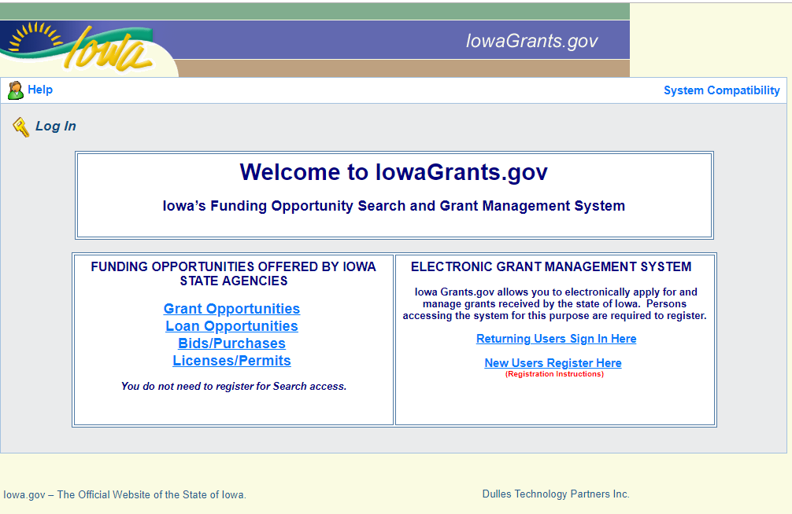

1. Click “New Users Register Here”
2. Enter your first and last name.

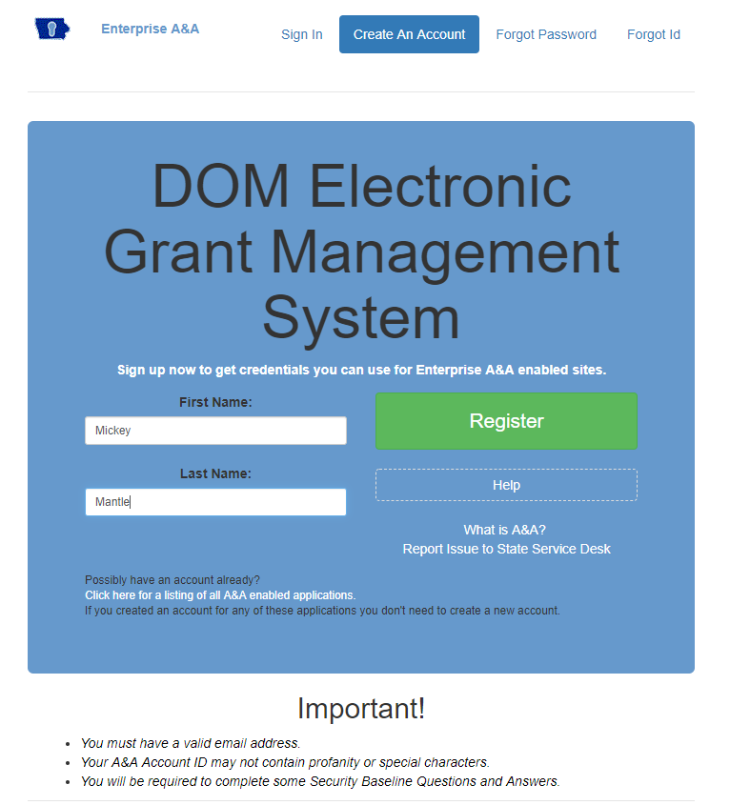

1. Choose an Account ID name. Please note, this will be your user ID in the system.

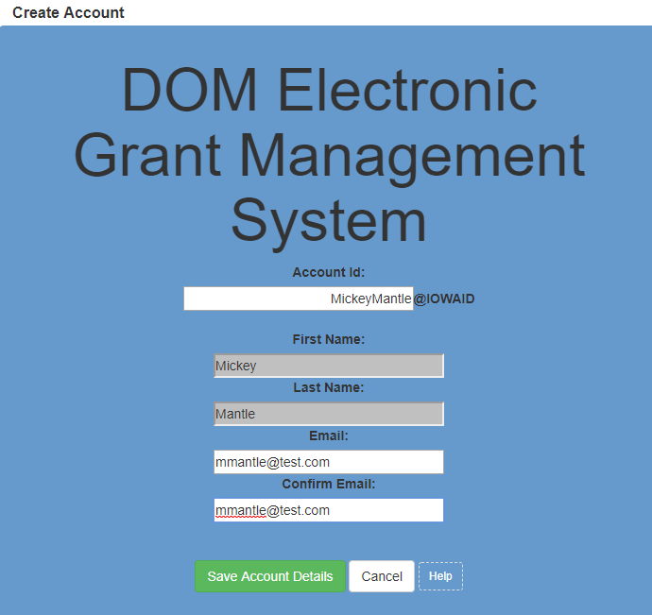

1. Click “Save Account Details.” You may receive a pop-up message that asks if you want to continue with your registration. Click “OK.”
2. Next you’ll receive a confirmation email.

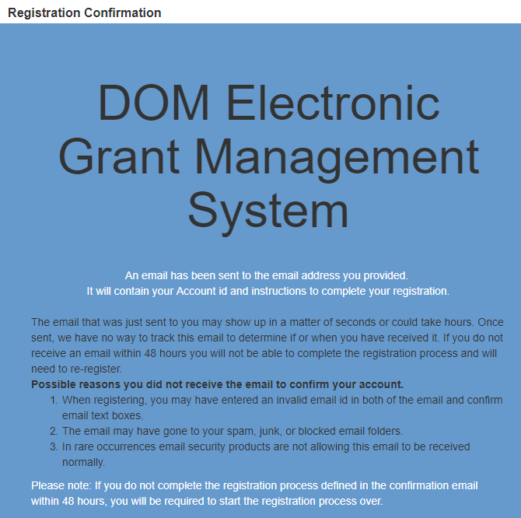

1. Open the confirmation email and follow the instructions. You’ll:
   1. Click a confirmation link
   2. Choose security questions
   3. Confirm a password
2. Go to IowaGrants.gov and into your account with your new username and password to finish activation.
3. Enter your basic information and select your Program Area of Interest.

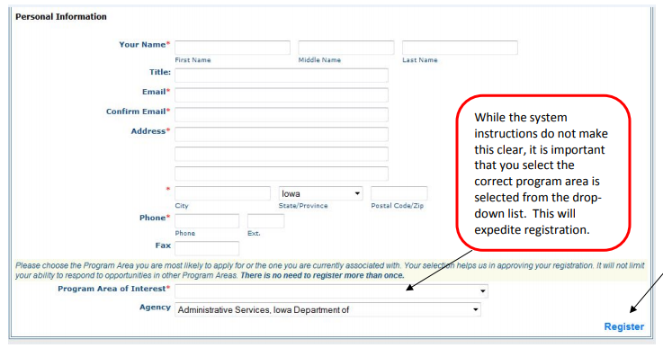

1. Click Register.
2. You’re registration is now pending final system approval. You will receive a confirmation email once approval is complete.

*If you have any questions regarding these instructions or want additional assistance, please contact David Parziale, IWD’s Grants Program Coordinator, at* [*david.parziale@iwd.iowa.gov*](mailto:david.parziale@iwd.iowa.gov) *or 515-725-9077.*