APPENDIX D: IowaGrants.gov New User Registration Instructions
Are you new to IowaGrants.gov? Follow these basic instructions to create an account and begin your grant application.
- Go to http://www.IowaGrants.gov
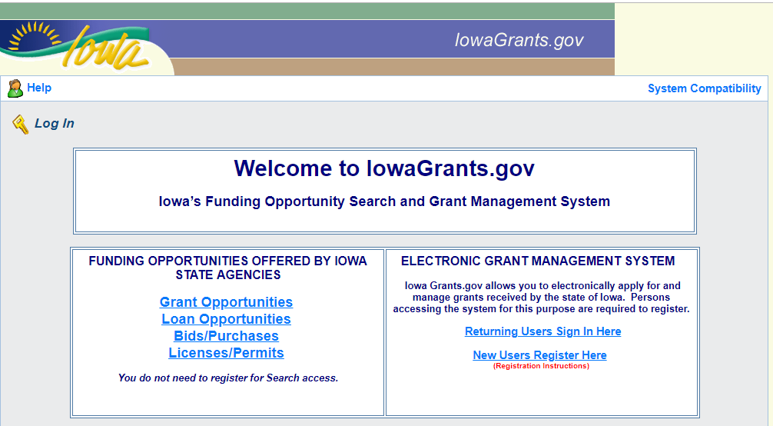
- Click “New Users Register Here”

- Enter your first and last name.
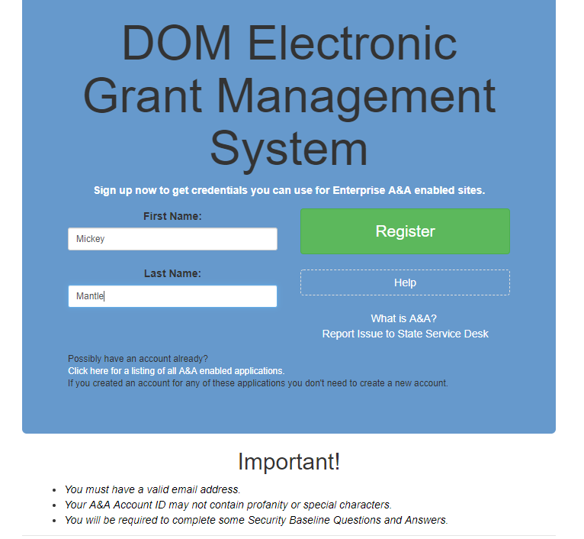

- Choose an Account ID name. Please note, this will be your user ID in the system.
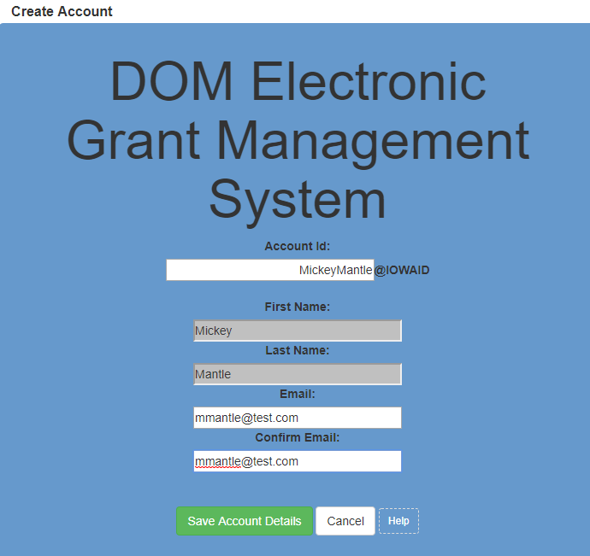

- Click “Save Account Details.” You may receive a pop-up message that asks if you want to continue with your registration. Click “OK.”

- Next you’ll receive a confirmation email.
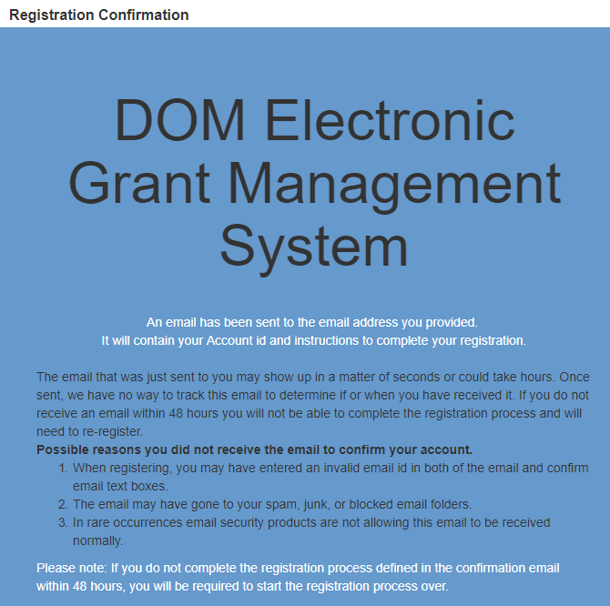

- Open the confirmation email and follow the instructions. You’ll:
  - Click a confirmation link
  - Choose security questions
  - Confirm a password

- Go to IowaGrants.gov and into your account with your new username and password to finish activation.

- Enter your basic information and select your Program Area of Interest.

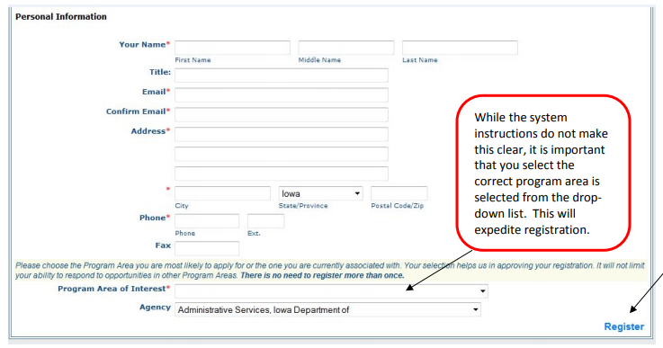

- Click Register.

- You’re registration is now pending final system approval. You will receive a confirmation email once approval is complete.

If you have any questions regarding these instructions or want additional assistance, please contact David Parziale, IWD’s Grants Program Coordinator, at david.parziale@iwd.iowa.gov or 515-725-9077.

